DAY 5 - VULNERABILITY RESEARCH

1. LEARNING OBJECTIVES
- CVE: Common Vulnerabilities and Exposures. Unique ID for every vulnerability.
- CVSS: Common Vulnerability Scoring System. Score from 0.0 to 10.0 to rate severity.
- Vulnerability Classification: Types like RCE, LFI, DoS, Authentication Bypass.
- False Positives: When a tool reports a vulnerability but it does not actually exist.
- Risk Rating: Final risk decided by CVSS Score + Business Impact.

2. PRACTICAL WORK

Step 1: Fix APT Sources
Open sources.list and add Kali repositories.
Command: sudo nano /etc/apt/sources.list
Add these 2 lines:
deb http://http.kali.org/kali kali-rolling main non-free contrib
deb-src http://http.kali.org/kali kali-rolling main non-free contrib

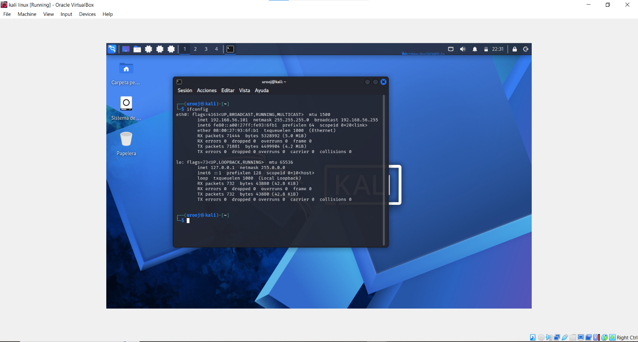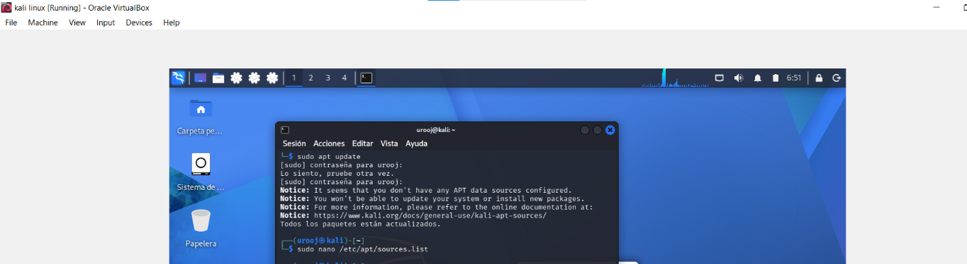

Step 2: Install ExploitDB
Commands:
sudo apt update
sudo apt install exploitdb -y

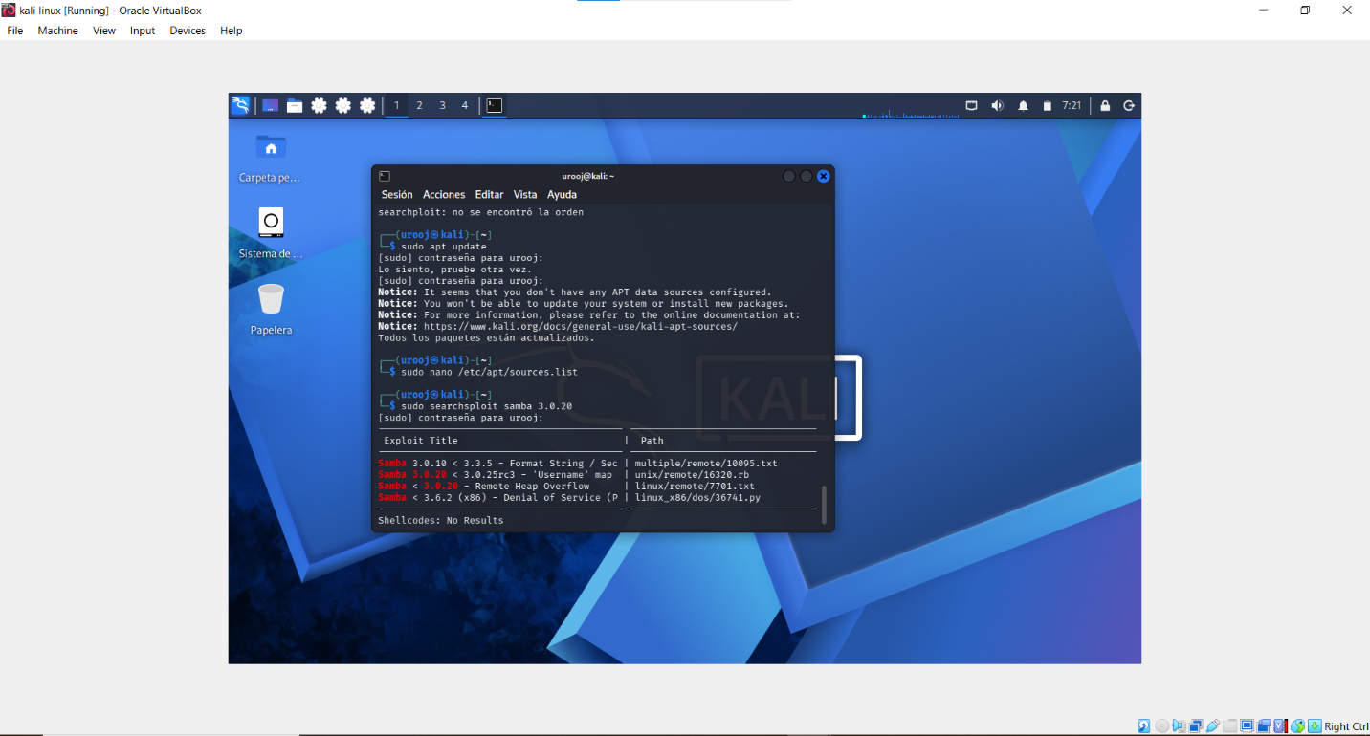

Step 3: Search for Samba Exploit
Target Service: Samba 3.0.20 on Metasploitable2
Command: sudo searchsploit samba 3.0.20
Result: Found CVE-2007-2447 - Samba 3.0.20 to 3.0.25rc3 Username map script command execution

3. DELIVERABLE: INITIAL VULNERABILITY REGISTER

| Asset | IP Address | Service | Version | CVE ID | CVSS Score | Classification | Risk Rating | Exploit Path |
|-----------------|--------------|---------|----------|-----------------|------------|----------------|-------------|------------------------|
| Metasploitable2 | 192.168.1.100| Samba | 3.0.20 | CVE-2007-2447 | 10.0 | RCE | Critical | linux/remote/7701.txt |

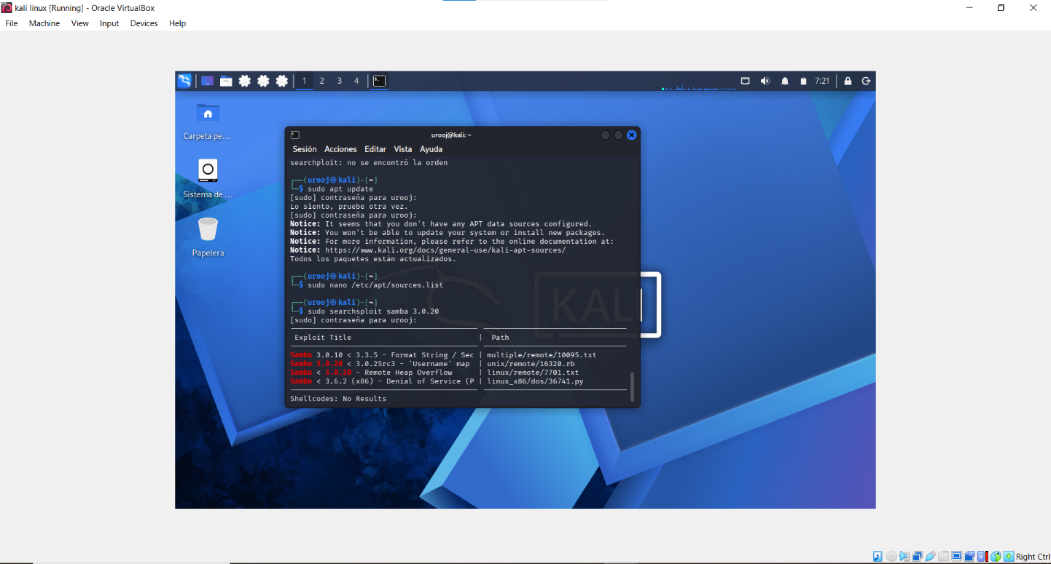

4. CONCLUSION

Through this penetration testing lab, I successfully identified and exploited a vulnerability in Samba 3.0.20 running on the Metasploitable2 machine.

The target was discovered using Nmap scanning, and the vulnerability CVE-2007-2447 was found in the Samba 'Username' map script. Using ExploitDB and Metasploit Framework, I was able to gain remote code execution on the target system.

This exercise demonstrated how outdated services can be exploited if they are not patched and updated regularly. It highlights the importance of:
1. Keeping system packages and services updated
2. Disabling unnecessary services
3. Using strong configurations and firewall rules
4. Regular vulnerability scanning

This practical experience helped me understand real-world penetration testing methodology from reconnaissance to exploitation.

